**Minimum Viable product**

It is very important to use the framework of build, measure and learn rather than just diving full-fledged into developing the product, the saying goes dream big, start small.

Test the waters first, then scale.

Learn for the initial build and measure cycle, then decide to persevere or pivot the idea. Persevere is to go on with the same idea along with minimal changes, whereas pivot is to change the approach altogether largely or marginally.

**Testing your MVP**

In order to test your MVP, you must identify the **correct target segment**as per the nature of your product. There are a lot of market research companies around that can help you do it, but ensure that you ascertain your core customer group beforehand.  It helps you take corrective action and avoid rework. Once you have tested out your MVP, it becomes imperative to know its**product adoption lifecycle**among different strata of your target customer segment.

In this video, you saw the application of the two methods of testing an MVP.

* Apple tested its products **in-house** as its target customer group was alike.
* Google let out its beta versions**open in the crowd** for getting a holistic feedback covering users across all age groups.

Also, Vishal from GOQii, highlighted the importance of constantly testing one’s MVP at every stage of product development.

You also learnt about the product adoption life-cycle.

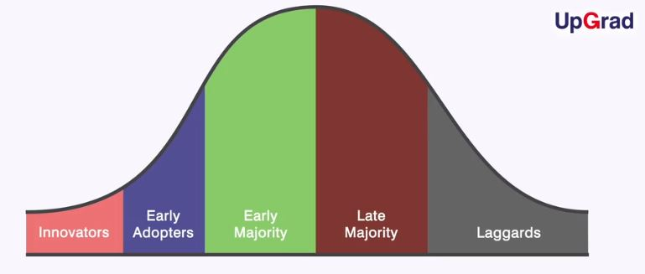

Product adoption life-cycle

Here, you saw that the **innovators and early adopters** are the perfect people for testing out your MVP.

On the product adoption lifecycle, Uber did pretty well in promoting its service by focusing on innovators and early adopters customer segments who are well connected, social media savvy and good at promoting through a referral network.

Additional readings

<https://startuprunner.com/minimum-viable-product-startups/>

[15 Ways to Test Your Minimum Viable Product (thenextweb.com)](https://thenextweb.com/news/15-ways-test-minimum-viable-product)